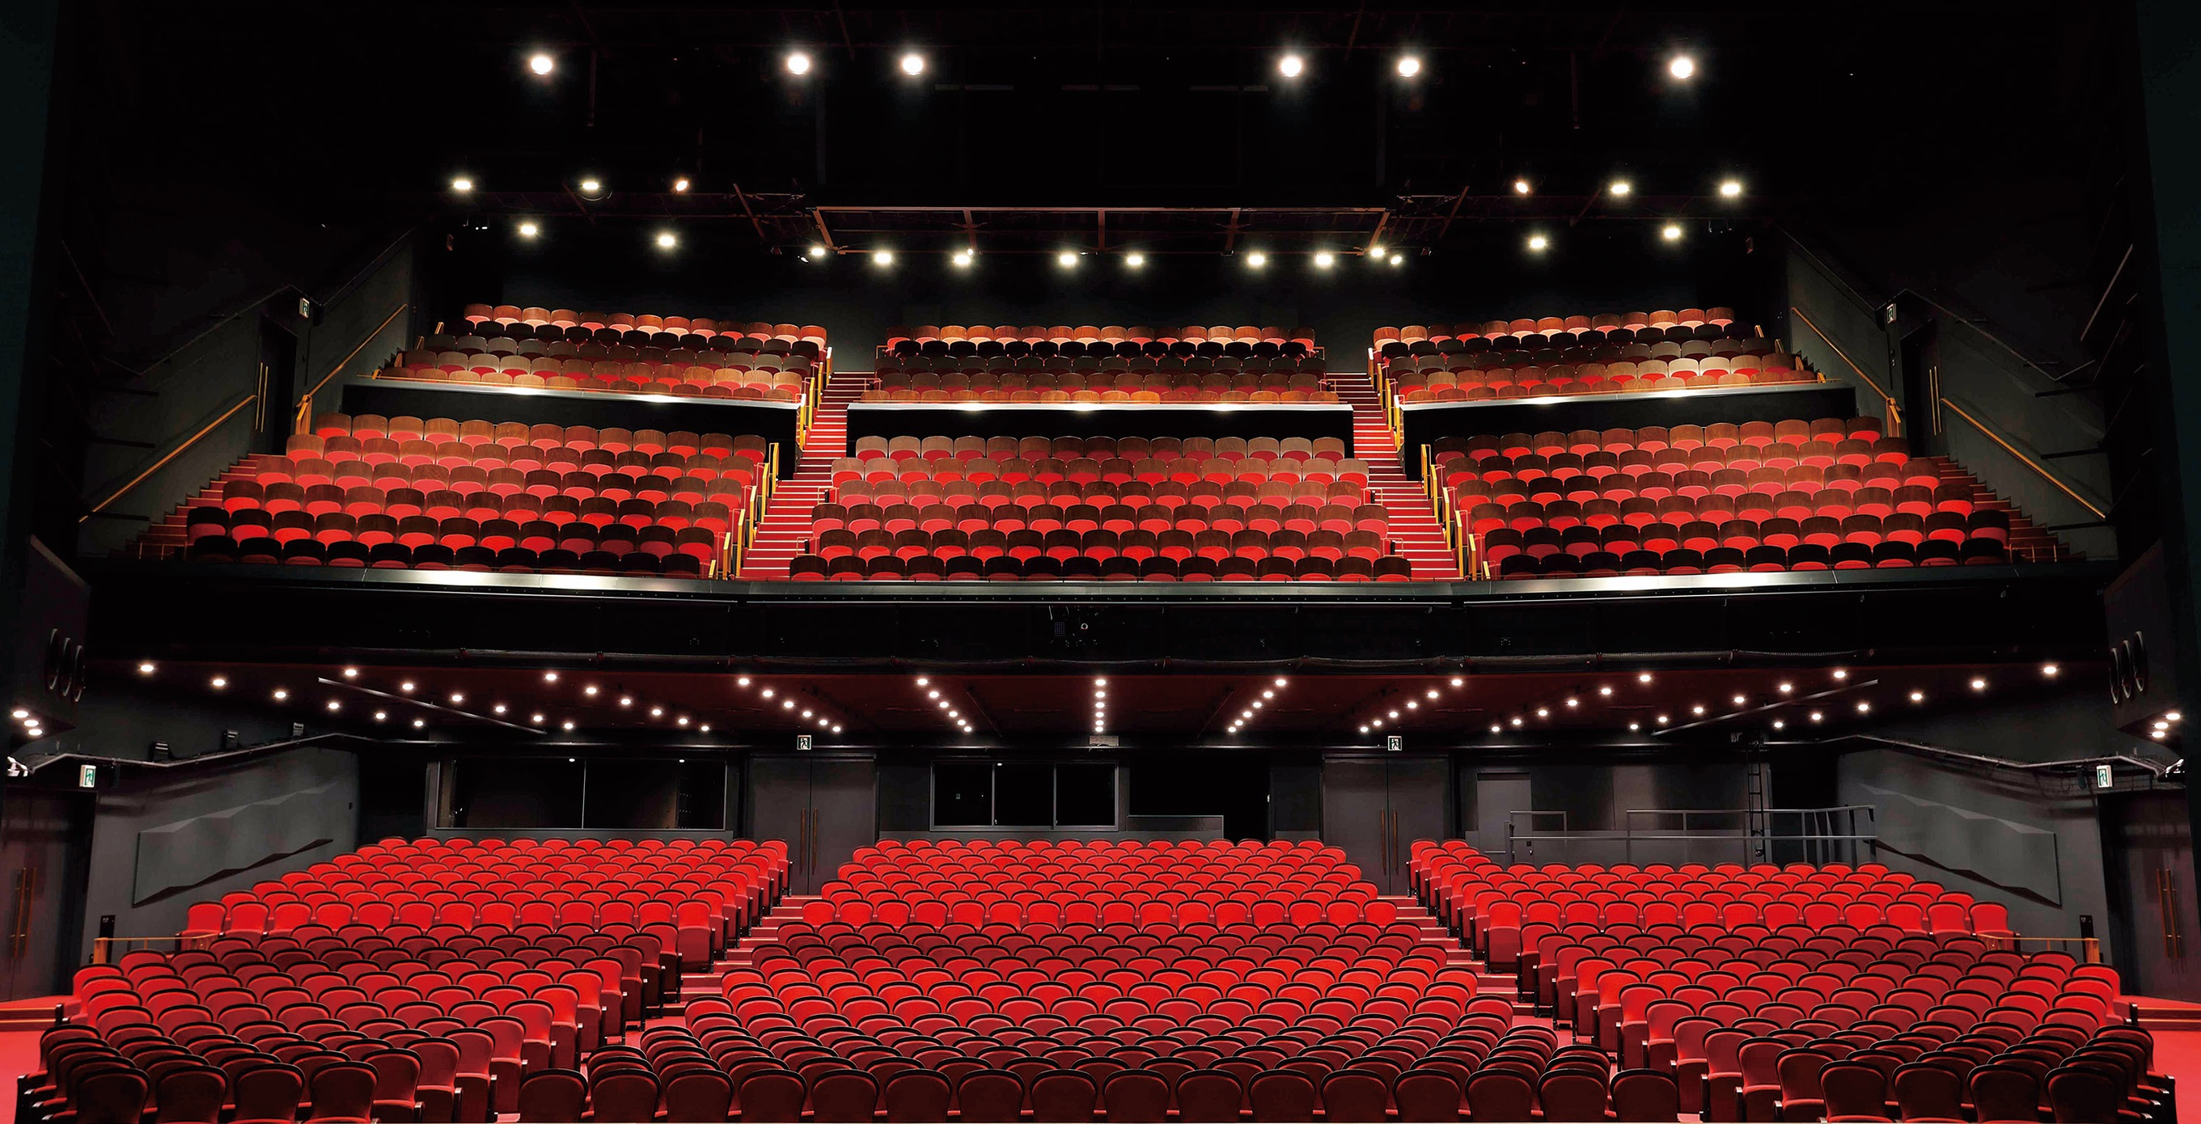
JR-EAST Shiki Theatre AKI interior view [Photo by Atsutoshi Shimosaka]

Shiki Theatre Company relies on Sennheiser Digital 6000 wireless

The Shiki Theatre Company has been leading Japan’s entertainment scene since 1953 and has become one of the world’s largest theatre groups with 1,400 actors and team members. Sennheiser Japan has been a reliable partner to the Shiki Theatre Company for many years. In the beginning, all their theatres were equipped with a combination of analogue Sennheiser 3000 series wireless receivers and 5000 series transmitters. After recognising the significant advantages of the Digital 6000 series, Shiki upgraded to the new audio system a few years ago.

Mr. Kaname Morishita from the Sound and Music Department of the Shiki Theatre Company talks about how the new digital system got introduced: “The major turning point was a sound designer in the US implementing the Digital 6000 series when we were preparing to stage new international programs at Shiki. For international productions, it’s common for the original sound designer to specify the equipment to be used, and unless there is no other specific requirement, we need to ensure the same quality of sound. Because of this, the Digital 6000 series was our top candidate.”

Kaname and the Shiki sound team visited the site of the original sound design to hear firsthand from users and stakeholders about Digital 6000 and its ease of use, which led to the decision to adopt the series. The equipment was delivered and put into operation just as setup for the new production began.

“The biggest advantage we noticed after starting to use it is that it’s small and lightweight. The SK 6212 bodypack transmitter weighs just 112 g and can, for example, be easily hidden inside a performer’s wig. If the transmitter were large, it would affect the shape of the wig, and if it were heavy, it would be a burden on the performer. The compact and lightweight design makes all the difference.”

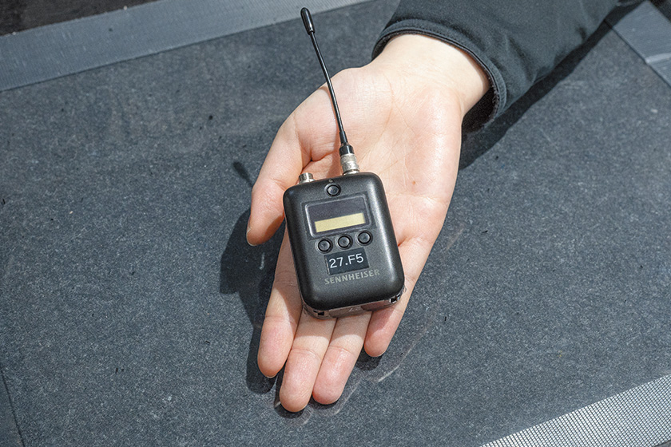 | The SK 6212 mini-bodypack transmitter is small and lightweight, and therefore easy to hide

Kaname also mentions the stability of the Digital 6000 series, which is a great support in environments where many channels are used at the same time. “The ability to use multiple channels simultaneously and stably is another advantage. Shiki Theatre Company’s productions have a large number of performers, and we also allocate backup channels for some of them. The number of channels currently in use is 44 for the theatre HARU and 42 for the theatre AKI.

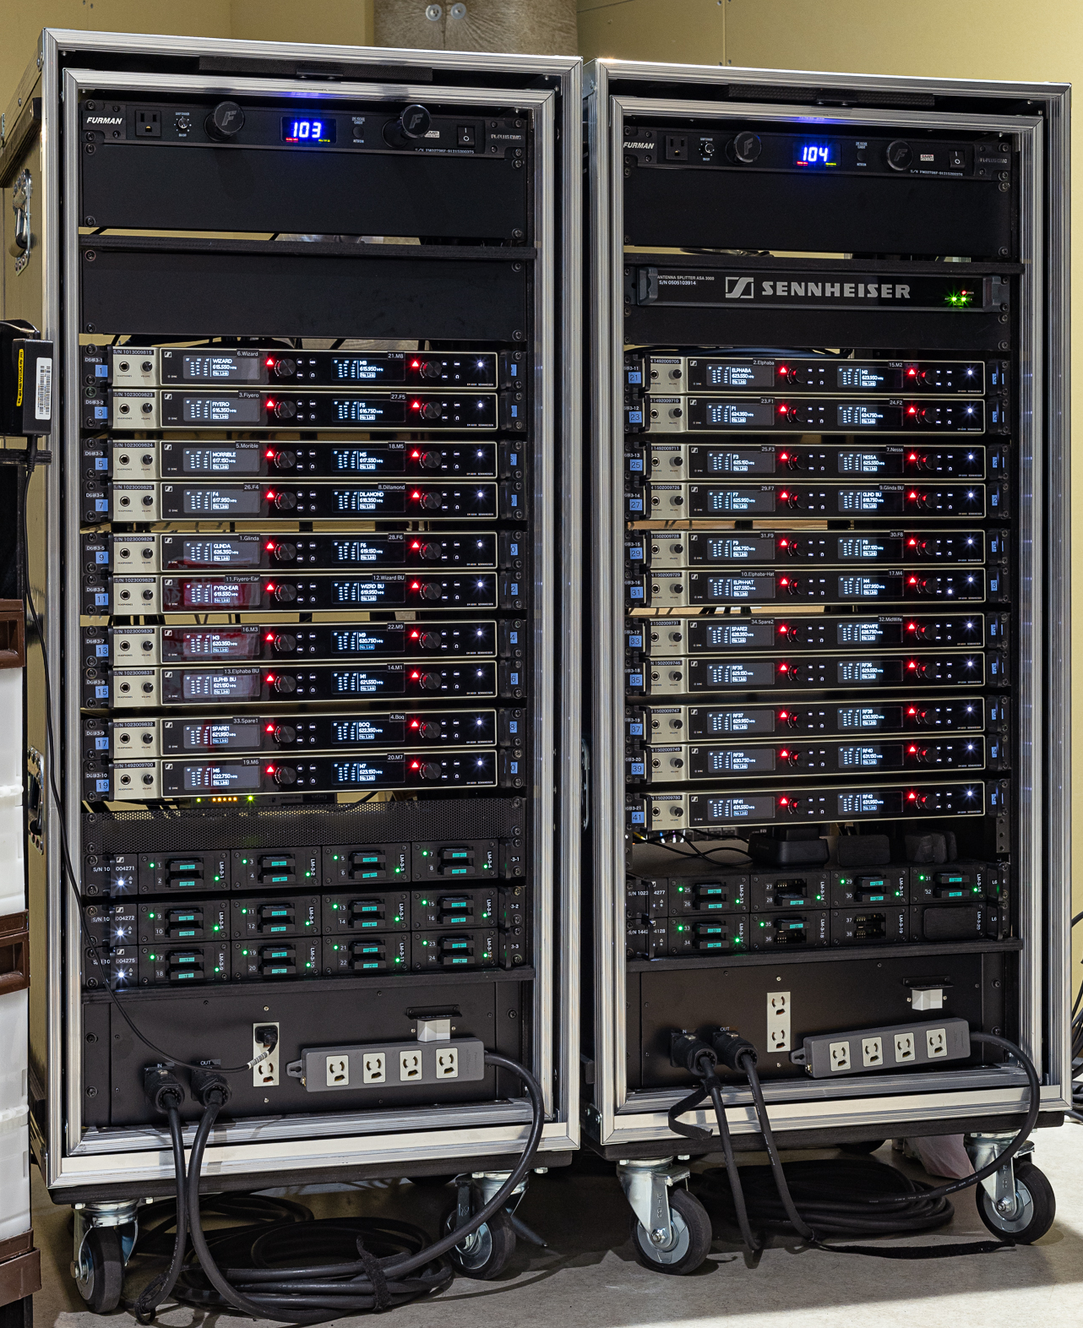 | The racks contain 21 EM 6000 Dante receivers as well as a L 6000 chargers for the mini bodypack transmitters

“Even when we use around 40 channels simultaneously in the adjacent theatres HARU and AKI, there is no interference,” Kaname notes, emphasizing the reliability of the system. He adds that the benefits extend not only to the sound staff but also to the performers.

The SK 6212 mini-bodypack transmitters operate in frequency ranges A5-A8 (550–638 MHz) and B1-B4 (630–713.8 MHz) | 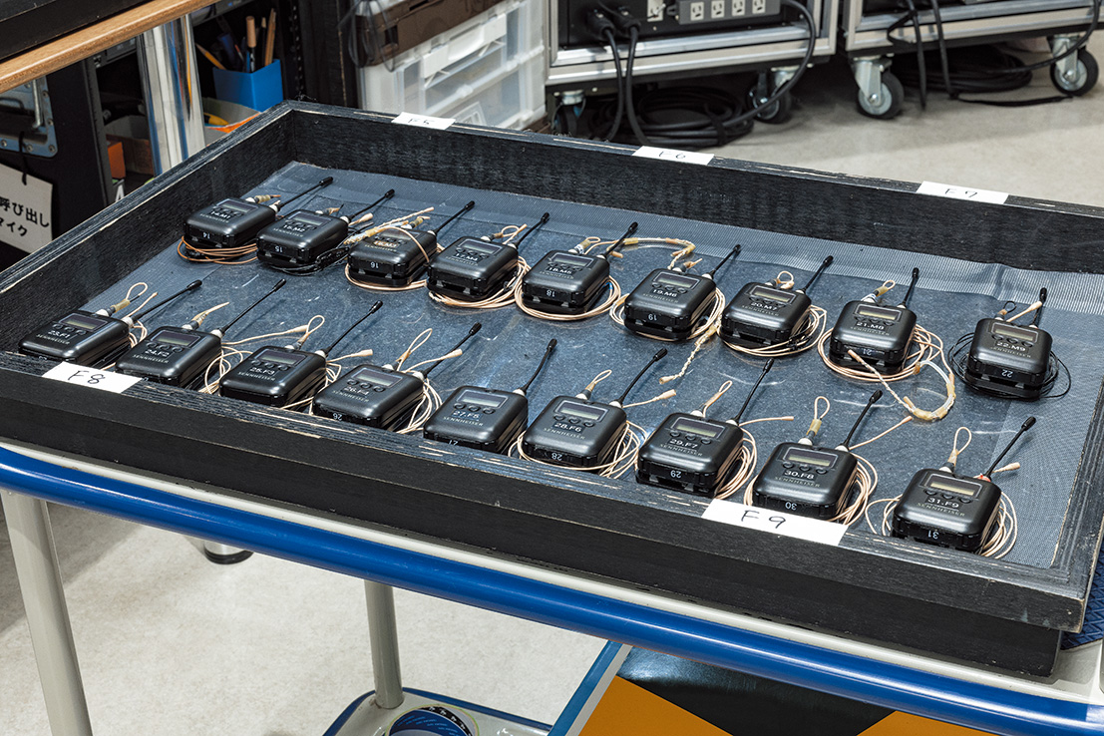

“We feel that the Digital 6000 Series meets what we are looking for in a wireless system. The perspective of managing the audio equipment, the ability to handle multiple channels stably, along with good battery life, durability, and waterproofing, are significant advantages. Additionally, the compact and lightweight design ensures comfort for the performers, makes it easier to conceal transmitters from the audience, and prevents the device from becoming too hot during extended use. Performers wear their costumes and wigs and have the transmitters on even before the performance starts, and once the performance begins, they move around under stage lighting, which makes it quite hot. In such conditions, not having to worry about heat is a major benefit.”

This article is a digest version of an article published in Sound & Recording on March 4, 2024.
Read the full article here (Japanese only)

The images accompanying this customer story can be downloaded here.

